

The University of Azad Jammu and Kashmir,
Muzaffarabad

Name | Kamal Ali Akmal
Course Name | Software Design & Architecture
Submitted to | Engr. Daniyal Nazeer
Semester | 3rd
Session | 2024-2028
Roll No | 2024-SE-38
Lab No | 07
Lab Title | Installation of Balsamiq Software

Installation and Usage of Balsamiq Wireframing Tool
Introduction
Balsamiq is a wireframing tool used for designing simple and low-fidelity user interface (UI) mockups. It helps designers and developers to visualize the layout of websites and applications before actual development. Balsamiq is widely used because of its easy interface and fast prototyping features.
Software Requirement
- Balsamiq Wireframes
- Operating System: Windows / MacOS
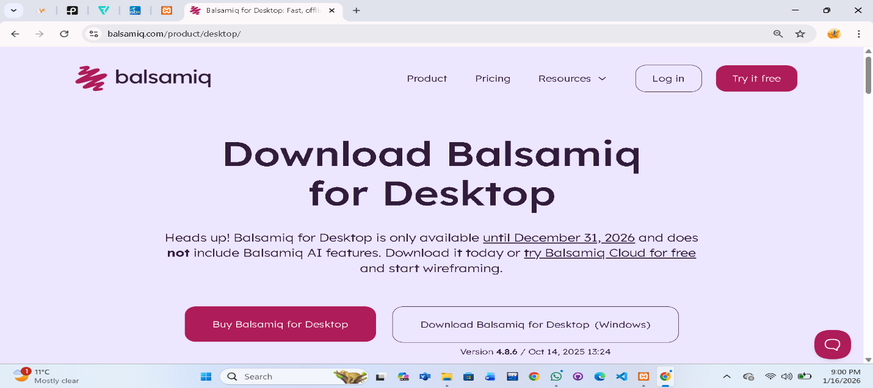
- Internet Connection
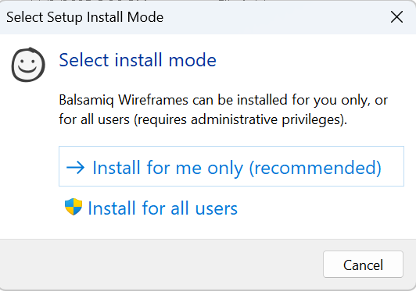

Downloading Balsamiq Software
- The website link https://balsamiq.com is entered in the address bar to open the official homepage.
- On the website, the Download button is clearly visible. By clicking on the download button, the Balsamiq setup file starts downloading on the system.
Selecting Installation Destination
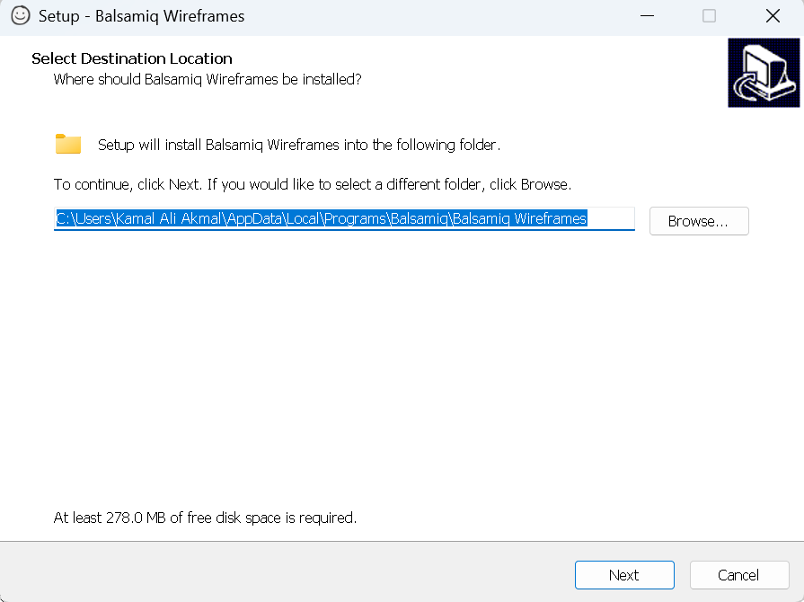

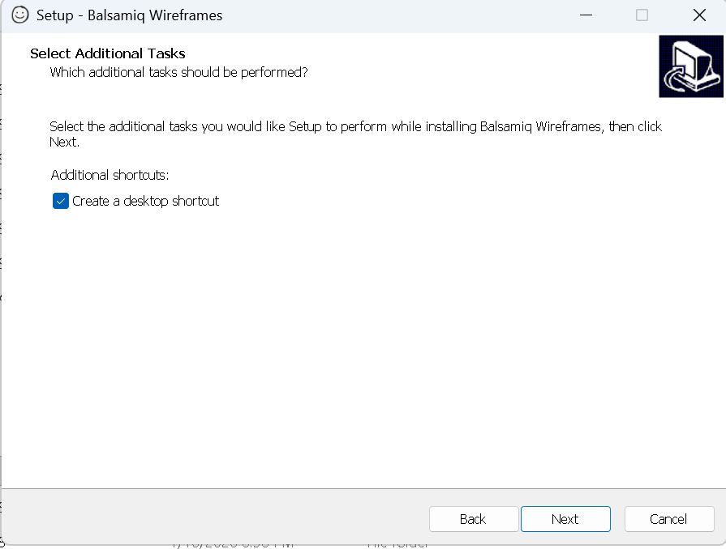
- During the installation process, the destination selection window appears.
- The default installation path is already selected, however it can be changed if required.
- After selecting the destination folder, the Next button is clicked to continue the installation.
Ready to Install the Software
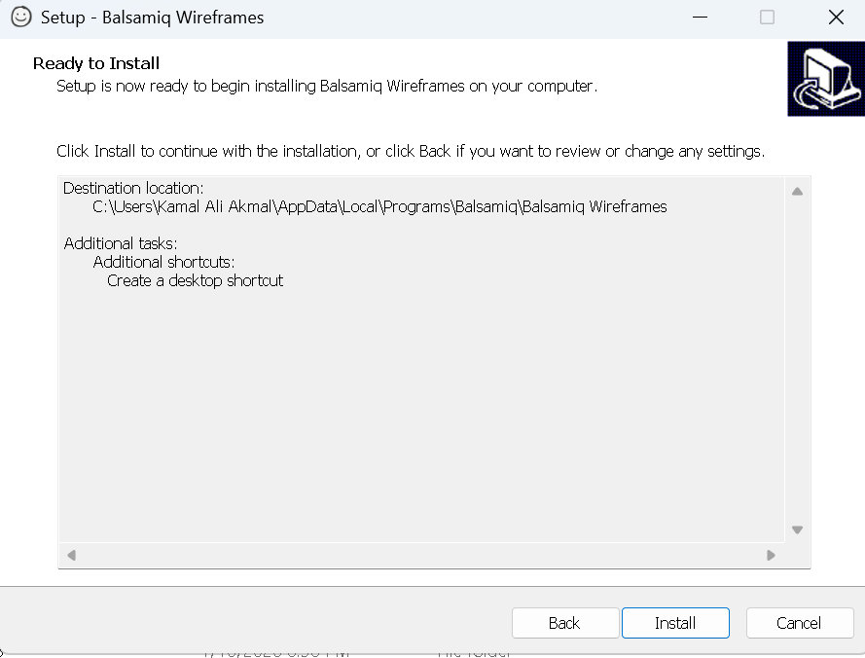
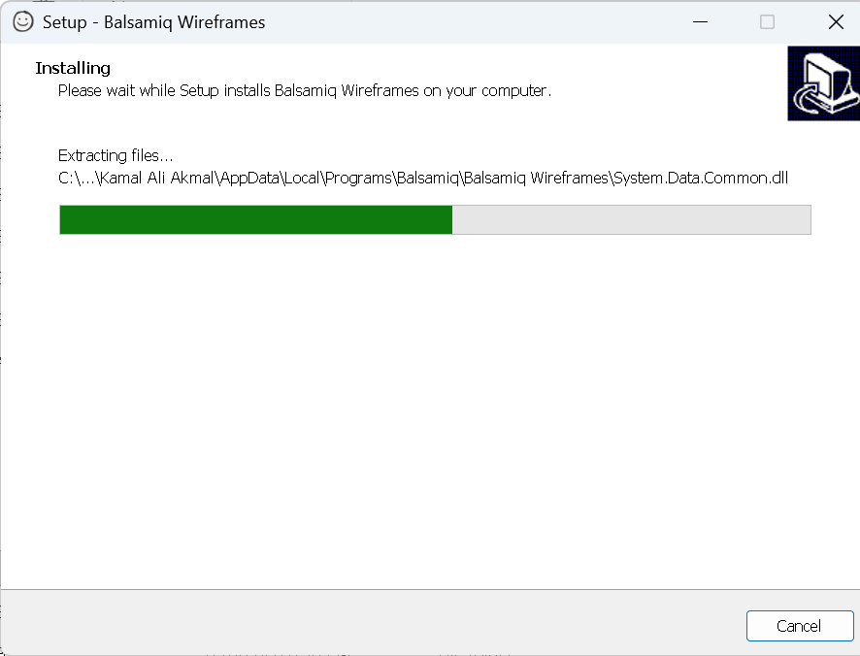
- This window displays the final installation settings.
- By clicking on the Install button, the installation process of Balsamiq software starts.

Installation Completed
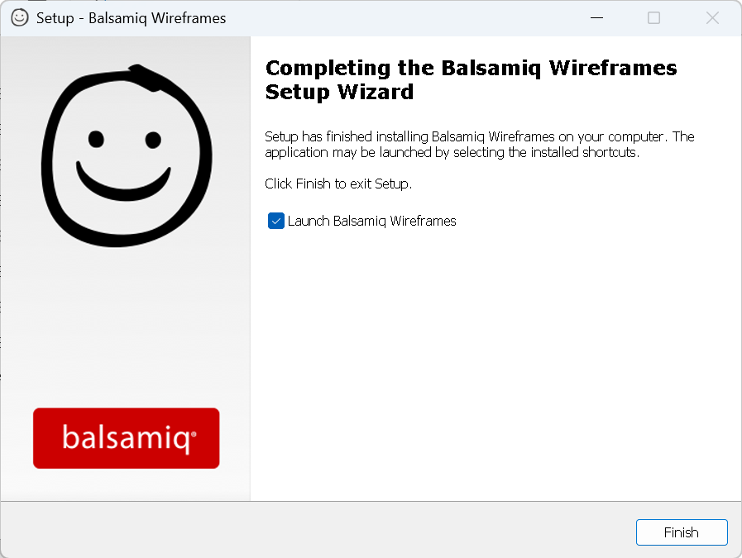
- The installation is completed and setup displays the installation complete window.
- By clicking on the Launch button, the Balsamiq software is opened successfully.
Balsamiq Software Interface
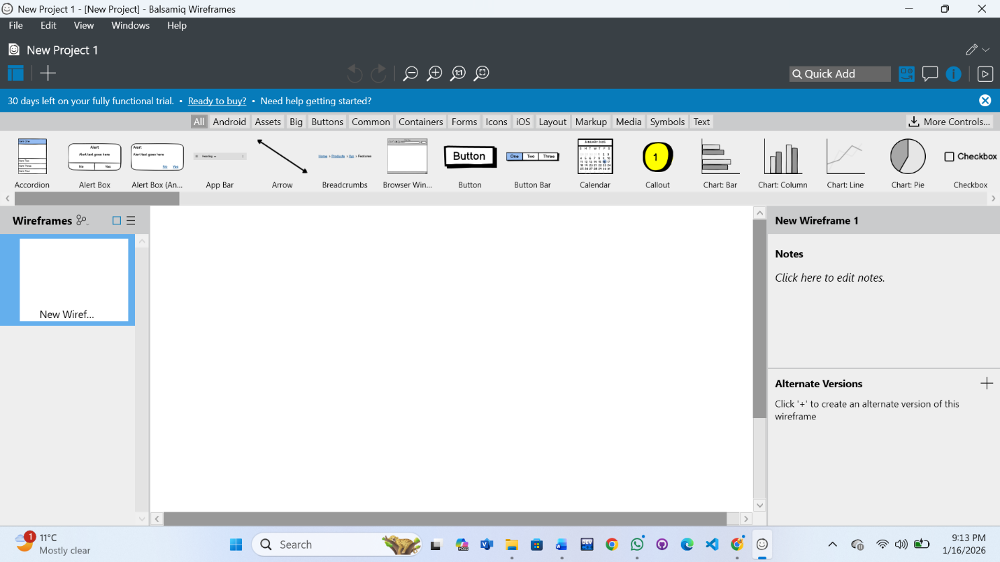
- After launching the software, the Balsamiq interface is displayed on the screen.
- This interface allows users to start creating wireframes and design layouts easily.
Conclusion
· Balsamiq is a user-friendly wireframing tool used for creating UI mockups.
· The software was successfully downloaded and installed from the official website.
· The installation process was simple and easy to follow.
· After installation, the Balsamiq interface was opened successfully for use.

